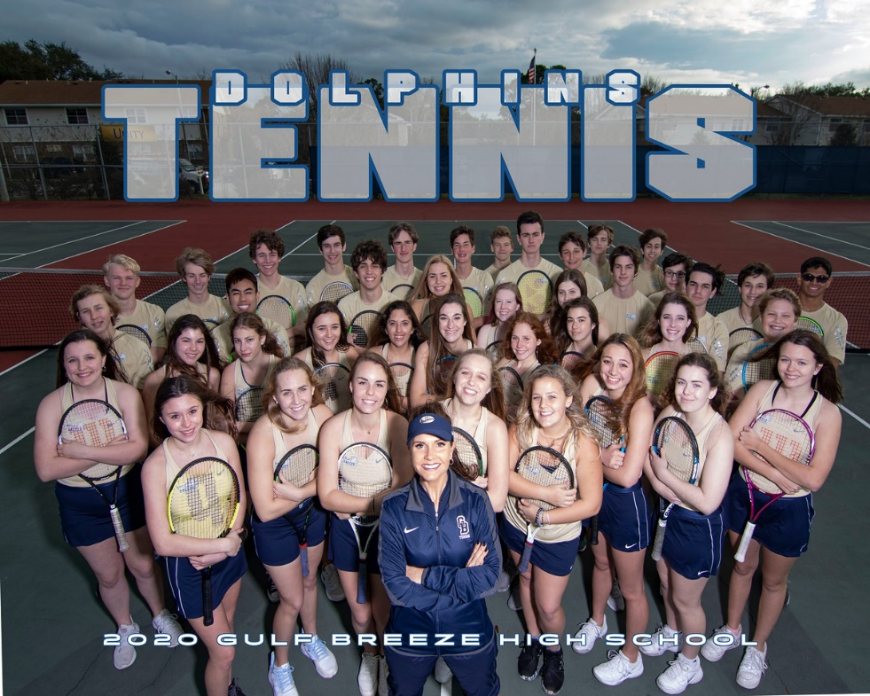
GBHS 2020 Girls Varsity GBHS 2020 Girls JV
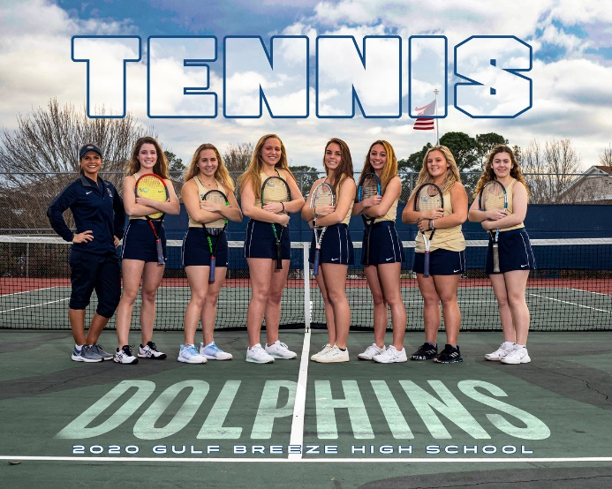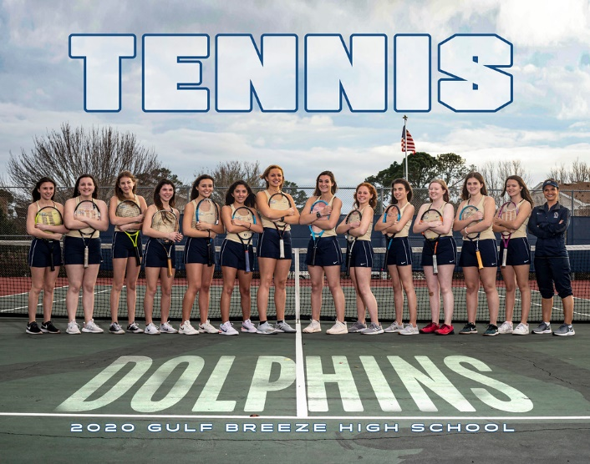
Head Coach Mitzi Schafer

Student/athlete meeting for 2021 GBHS Tennis season: January 13th Time TBA
Sign up in the Administration Office
2021 GBHS Tennis tryouts January 18-21, 2021
2021 First practice starts January 25th
2021 Parents Meeting January 26th : Time/Location TBA

Requirements to participate in GBHS Athletics:
- Must have a physical + concussion testing on file in Athletic Department
- Off campus form completed and turned in to Administration office.
- Created a Athleticclearance.com account with all forms uploaded
- Find all forms at: http://gulfbreezedolphins.com/forms/
NO Physical+ NO Forms + NO Athletic Clearance = NO Tryouts
Must be cleared by January 14, 2021 to tryout. NO EXEMPTIONS!
If participating in another GBHS Sport program, please contact Coach Schafer prior to January 18th for alternative tryout dates.
Please contact Coach Schafer to be added to communications for tennis
Contact: Coach Mitzi Schafer
schafermk@santarosa.k12.fl.us

